

BCSE417L – MACHINE VISION LAB

EXPERIMENT 1: CHANGING THE COLOR MODEL

SUBMITTED BY-
22BAI1118 – Mayank Raj

SUBMITTED TO-
Trilok Nath Pandey
Date: 15/12/2024

Aim:
The objective of this lab exercise is to understand and implement the display of images using different color models in Python. You will work with various libraries to manipulate and visualize images in RGB, Grayscale, HSV, and CMYK color models.

Data Set used (photo):


Instructions:

Part 1: Converting the Image to All Color Models
Open the Jupyter Notebook in your Python environment.
In Cell 4, update the variable image_path with the path to the image you want to process (e.g., "path/to/your/image.jpg").
Run Cell 4 to:
Convert the image to Grayscale, HSV, and CMYK color models.
Display the original and converted images.
Save the converted images (Grayscale, HSV, and CMYK) to the same directory as the Notebook.
Part 2: Interactive Color Model Conversion
Run Cell 5.
Input the path to your image when prompted.
Choose the desired color model (grayscale, hsv, or cmyk) by typing it when prompted.
The program will:
Convert the image to the specified color model.
Save the converted image to the current directory.
Display the converted image in the output.

Note: Ensure the image file is accessible and in a supported format (e.g., JPG, PNG). Install the required libraries (opencv-python, numpy, and matplotlib) before running the Notebook using:

Output:
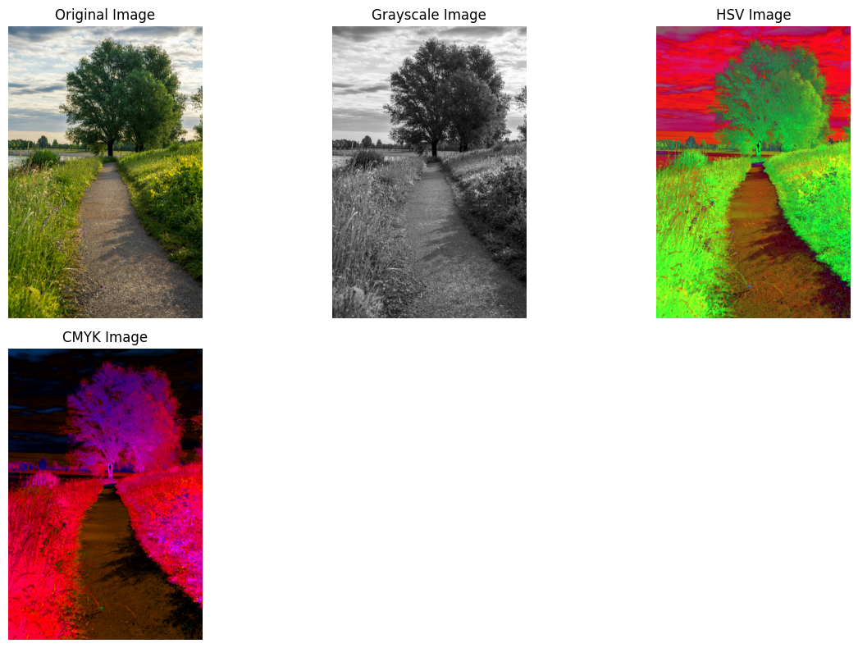


Color models:
1. Red, Green, and Blue
Red, green, and blue color are used in the RGB color model to produce various color. Each color is created by blending these three primary colors in different intensities, and it is primarily utilized in screens and digital displays.

2. Grayscale
Images displayed in grayscale, which is a color model that ranges from black to white, are grayscale. It's frequently employed in applications where color isn't crucial because it simplifies analysis by emphasizing brightness.

3. Hue-Saturation-Value
The HSV color model uses hue (the type of color), saturation (the color's vibrancy), and value (the color's brightness) to describe colors. When distinguishing colors from brightness is required for activities like image processing, it might be helpful.

4. Cyan-Magenta-Yellow-Black
CMYK is a color model used for printing, combining cyan, magenta, yellow, and black inks to create colors. Unlike RGB, it works by subtracting light, which means it removes certain wavelengths to show colors.

Result Analysis Report:
- Objective Achieved
The program successfully achieves its objective of loading an image and converting it into different color models: Grayscale, HSV, and CMYK. The converted images are displayed and saved correctly without any errors.
- Functionality
- In Part 1, the program converts the input image to all specified color models and saves them in the desired formats. It also displays the images using matplotlib for visual verification.
- In Part 2, the program interacts with the user to accept the image path and the desired color model for conversion. It converts the image accordingly, displays the result, and saves it.
